## The Six Distance Markers (part 2)

### The Angle Marker Tool

This tool enables you to show angle degrees on your plan.

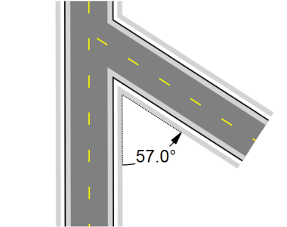

The_Angle_Marker_Tool

**To place an Angle Marker:**

* Select the **Angle Marker** tool from the Marker tab in the Tools Palette.
* Click the space you wish to measure (the first click will be the angle measured)
* Click a second time to mark the base point of the angle.
* Drag your mouse in the direction you want to measure and click to finish the angle once it is set to the desired degree/location.
* 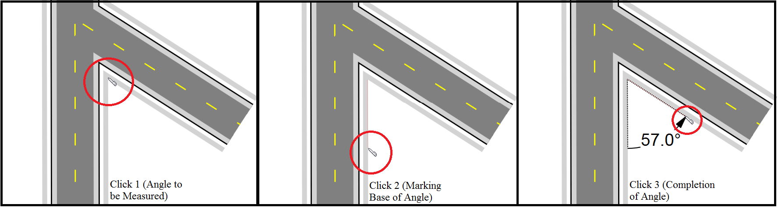
* Placing_the_Angle_Marker
* **Note:** Like any item in RapidPlan, the angle marker, once made, can be moved and adjusted, with the degrees changing accordingly.
* ### The Area Marker Tool

This tool calculates the area you allocate which is shown as the cross-hatched netting in the image below.

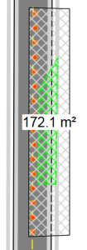

The_Area_Marker_Tool

**To place an Area Marker:**

* Select the **Area Marker** tool from the Marker tab in the Tools Palette.
* Left click once to start drawing.
* Continue clicking to set corner points of the area.
* Right click to finish.

### The Combined Offset Distance Marker Tool

This tool allows you to create a combined marker that is offset on your plan.

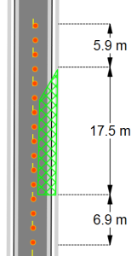

The_Combined_Offset_Distance_Marker_Tool

**To place an Combined Offset Distance Marker:**

* Select the **Combined Offset Distance Marker** tool from the Marker tab in the Tools Palette.
* Left click once to start drawing the distance marker, left click again to end the first distance marker and start the second.
* Repeat this until you have all of your distances for that marker.
* To finish the last distance press right click.
* Drag your mouse laterally away from the distance marker to set the offset. Click a third time to finish drawing the marker.
* Right click to finish.

### The Distance marker breakline

When not drawing to scale, use the Breakline property of a Distance Marker to indicate whether the marker symbolically represents a larger on-site distance.

To enable the breakline, simply select the distance marker, in its Properties there is a subheading for Breakline.

Simply change it from False to True and it will set the breakline in the middle of your marker. You can also adjust the size directly underneath.

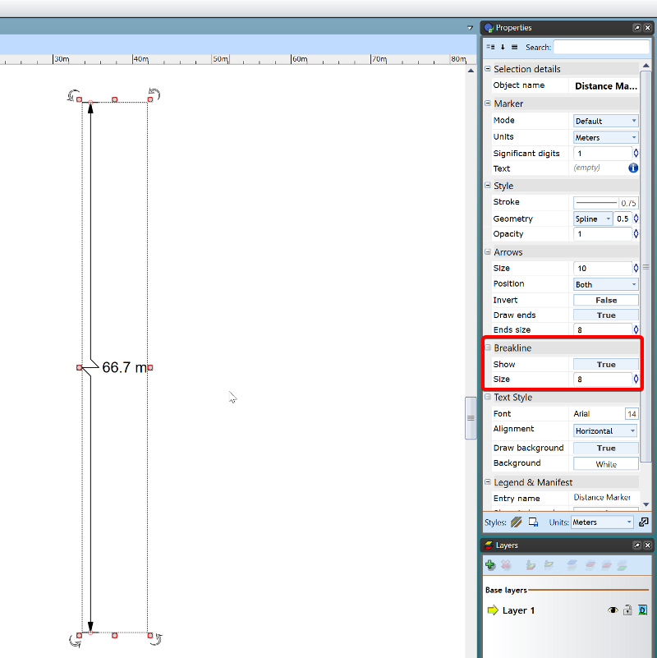

Marker_Breakline